WHITFIELD & CRANE LLP

URGENT NOTICE OF
FRAUDULENT FUNDS

FINANCIAL TRANSACTION FORENSICS / CASE RECORD
TO: COMPLIANCE DEPT | CASE NUMBER
Wise Payments Limited | #WC-2026-FX7717
FROM | SUBJECT
Whitfield & Crane LLP | Urgent Notice of Fraudulent Funds
TARGET ACCOUNT | CARD REFERENCE
Toby A Blackburn | #8842

01. NOTICE OF KNOWING RECEIPT
The funds currently held in the account of Toby A Blackburn (Card ending in #8842) on your platform are the direct proceeds of cyber fraud. Tracing evidence confirms these funds entered this account after 167 layers of offshore and cryptocurrency mixing laundering. Your AML monitoring systems failed to intercept this illicit activity.

02. LEGAL LIABILITY WARNING

Effective upon receipt of this notice, your company is deemed to have "Actual Knowledge" of the illicit nature of these assets under the law. Should you permit the suspect to dissipate these funds, your institution will face liability for constructive trust, knowing receipt, and facilitating money laundering, along with joint and several claims for damages.

03. DEMANDS FOR IMMEDIATE ACTION
• Immediately freeze all funds held under the account of Toby A Blackburn (Ending #8842).
• Preserve all KYC registration data and IP login records associated with this account pending subpoenas from law enforcement authorities.

Counsel Signature:  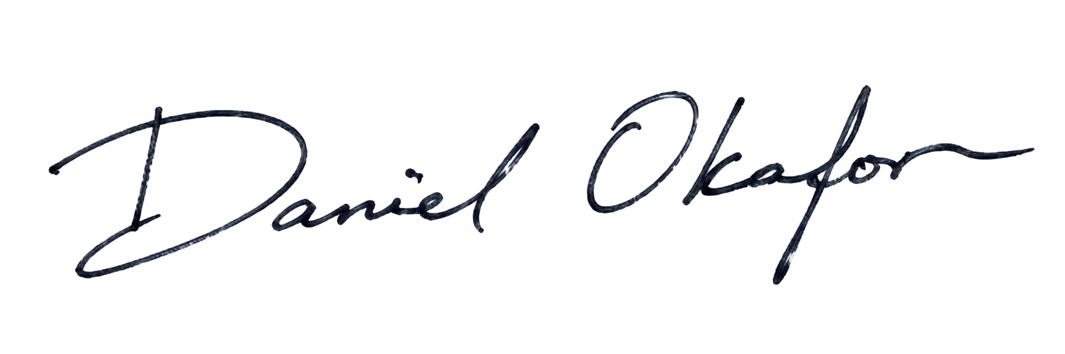 | 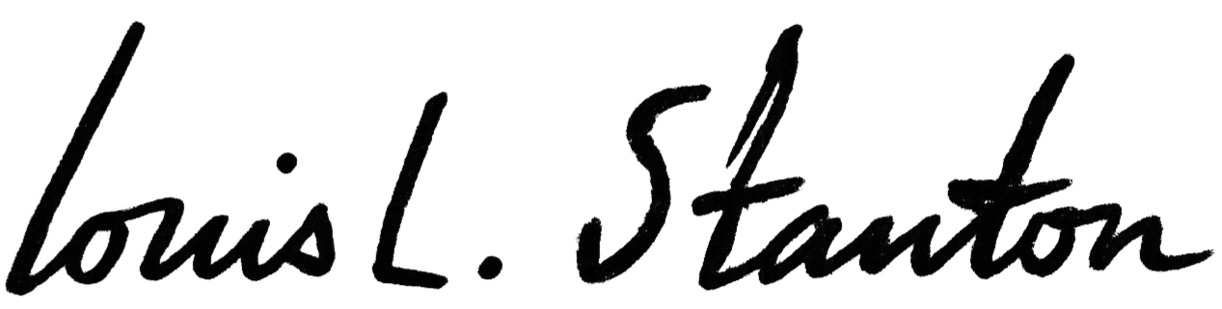  Judge Signature:
Name: | Name:
当天日期 | 当天日期

